VERDANA  Excellence in Every Extract  100% HAND NO  ORGANIC PICKED ADDITIVES  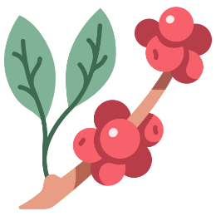  First Light  Loose Leaf Tea  ORIGIN : Darjeeling, India  BREW TEMPRATURE: : 80°C / 176°F  STEEP TIME : 2-3 Minutes  BEST BEFORE : Dec, 2016  “A delicate floral infusion from the misty highlands of Darjeeling, harvested at first flush.” |  | VERDANA  Excellence in Every Extract  100% HAND NO  ORGANIC PICKED ADDITIVES    First Light  Loose Leaf Tea  ORIGIN : Darjeeling, India  BREW TEMPRATURE: : 80°C / 176°F  STEEP TIME : 2-3 Minutes  BEST BEFORE : Dec, 2016  “A delicate floral infusion from the misty highlands of Darjeeling, harvested at first flush.”
VERDANA  Excellence in Every Extract  100% HAND NO  ORGANIC PICKED ADDITIVES    First Light  Loose Leaf Tea  ORIGIN : Darjeeling, India  BREW TEMPRATURE: : 80°C / 176°F  STEEP TIME : 2-3 Minutes  BEST BEFORE : Dec, 2016  “A delicate floral infusion from the misty highlands of Darjeeling, harvested at first flush.” |  | VERDANA  Excellence in Every Extract  100% HAND NO  ORGANIC PICKED ADDITIVES    First Light  Loose Leaf Tea  ORIGIN : Darjeeling, India  BREW TEMPRATURE: : 80°C / 176°F  STEEP TIME : 2-3 Minutes  BEST BEFORE : Dec, 2016  “A delicate floral infusion from the misty highlands of Darjeeling, harvested at first flush.”

